

The Effects of Repeated Sprint Training with Varying Inter-Rep Rest Intervals on Performance Outcomes in Semi-Professional Male Soccer Athletes

Exam Number: B235956
Course: REDU11011
Course Organiser: Dr Sarah Morton
Course Supervisor: Dr Matthew Weston
Date of Submission: 12/04/2024
Word Limit: 2500

MSc Strength and Conditioning
2023 – 2024

The Effects of Repeated Sprint Training with Varying Inter-Rep Rest Intervals on Performance Outcomes in Semi-Professional Male Soccer Athletes

Introduction and Research Question:

In intermittent team sports like soccer, players cover up to 9-16 km of total distance, with high-intensity running and sprinting accounting for up to 12% and 11% of this distance, respectively, with 83% of goals preceded by decisive actions such as short sprints or jumping, during a match (Sarmento et al., 2014) (Rampinini et al., 2007) (Faude et al., 2012). Players are also required to perform repeated high-intensity accelerations (30 ± 7, at > 3 ms⁻²), decelerations (56 ± 12, at > (- 3 ms⁻²)), and changes of direction (~700 times per game) while lasting for 90 minutes plus (Oliva-Lozano et al., 2020) (Oliva Lozano et al., 2022). Hence, the ability to perform repeated high-intensity actions (e.g., repeated sprints, accelerations, decelerations, changes of directions, and high-speed runs) and recover from them across the duration of a match is crucial for match success (Stølen et al., 2005). Therefore, performance outcomes, including but not limited to Repeated Sprint Ability (RSA), Maximal Sprint Speed, Acceleration, Deceleration, Changes of Directions, Countermovement Jump (CMJ) Height, and Aerobic Capacity/Maximal Oxygen Consumption (VO_{2max}), should be developed holistically to help players cope with match demands and improve their success outcomes (Chmura et al., 2022) (Owen, 2023) (Bortnik et al., 2023) (Bishop et al., 2011) (Taylor et al., 2015).
The performance outcomes mentioned above can be enhanced using a combination of various training methodologies, including but not limited to Interval Training (for improvements in Aerobic Capacity, Fatigue Index, Lactate Threshold, and RSA Decrement), Strength/Power Training (for improvements in Strength and Power), High Intensity Training ( > VO_{2max}, for improvements in Anaerobic Capacity), and Sprint Specific Training (for improvements in Maximal Sprint Speed, RSA best time, RSA total, and Acceleration) (Girard et al., 2011) (Bishop et al., 2011) (Owen, 2023) (Laursen & Buchheit, 2019). However, team sports such as soccer demand players to manage congested match fixtures, with most of their time dedicated to technical and tactical training. As a result, prescribing multiple training modalities to elicit the required physical conditioning objectives across training blocks is challenging for practitioners due to the limited time available for physical conditioning and constraints on pushing players’ workload. (Turner & Stewart, 2014) (Freitas et al., 2021). In light of this, a contemporary training method known as Repeated Sprint Training (RST), which involves maximal effort, short-duration sprints (≤ 10 s) interspersed with brief (≤ 60 s) recovery periods, can be prescribed to target the development of both neuromuscular and metabolic functions to elicit multiple adaptations simultaneously and save crucial time while managing players’ workload (Girard et al., 2011) (Taylor et al., 2016) (F. Thurlow et al., 2023). RST aims to create perturbations in the muscle metabolic milieu and ion homeostasis, resulting in positive adaptations, including improvements in oxidative capacity, phosphocreatine recovery, H+ buffering, muscle activation, and recruitment strategies (Bishop et al., 2011) (Meckel et al., 2009). Evidence also suggests that running-based RST performed over a short period (2-5 weeks) improves several other physical and physiological qualities pertinent to soccer success, including CMJ height, high-intensity intermittent running performance, acceleration, linear sprint speed, sprint times, aerobic capacity, blood lactate buffer capacity, change-of-direction ability, and RSA (Taylor et al., 2016) (F. Thurlow et al., 2023) (Negra et al., 2023).
When prescribing various training methodologies, manipulating the structure of the training session (e.g., rest intervals, rest redistribution, volume, load, etc.) may alter performance outcomes and internal, external, and perceptual responses to training. One method of structuring training sessions that acutely maintain mechanical performance is implementing different inter-rep rest intervals and rest re-distribution (Jukic et al., 2020) (Hill-Haas et al., 2007). However, unlike resistance training, the effects of different inter-rep rest intervals and rest re-distribution in RST are not well established. Only a handful of investigations have been done so far, warranting more investigations for a clear understanding, especially regarding different inter-rep rest intervals (F. Thurlow et al., 2023) (J. Weakley, A. Pérez Castilla, et al., 2023).
Recent meta-analyses have shown the use of a 20-second inter-rep rest interval for a sprint distance of 30 meters to 40 meters as the most common RST prescription, resulting in a work-to-rest (W:R) ratio of roughly (1:4) (Fraser Thurlow et al., 2023) (F. Thurlow et al., 2023). However, most of the studies that have directly investigated the effects of varying inter-rep rest intervals during RST have chosen much broader (short vs long) W:R ratios (1:1 vs 1:6) and (1:3 vs 1:6) (Saraslanidis et al., 2011) (Iaia et al., 2017). Also, these studies had a low volume of repetitions, the involvement of not well-trained but fit participants, youth population, performance outcomes fixed to 80-300 m sprints (i.e., no endurance or RSA evaluation), and no significant changes in aerobic capacity which conflicts with the outcomes of recent meta-analyses done by (F. Thurlow et al., 2023) (Fraser Thurlow et al., 2023) and limits the study's relevance/applicability to the adult soccer population.
Hence, none of the studies have directly explored the comparative effects of relatively narrower W:R ratios for inter-rep rest intervals compared to standard protocol, such as (10s vs 20s | 1:2 vs 1:4) in semi-professional male soccer athletes. Therefore, this study aims to empirically test the effects of RST with relatively narrower W:R ratios for inter-rep rest intervals compared to standard protocol (10s vs 20s | 1:2 vs 1:4) on performance outcomes in semi-professional male soccer athletes to add new knowledge to the repertoire of RST prescriptions and provide actionable insights to practitioners into manipulating training variables such as inter-rep rest interval and their effects on athletes' performance outcomes.
The following question will be investigated in this study:
1. Quantifying the Magnitude and Direction of Effects due to different inter-rep rest intervals on Performance Metrics such as CMJ, Maximal Aerobic Speed(MAS), Sprint Times, Maximal Sprint Speed, Heart Rate (HR), Differential Ratings of Perceived Exertion (dRPE), and Training Load (TL).

Table 1: Abbreviations

RSA: Repeated Sprint Ability | MSS: Maximal Sprint Speed
CMJ Height: Countermovement Jump Height | RST: Repeated Sprint Training
VO_{2max}: Maximal Oxygen Consumption | LSS: Linear Sprint Speeds
W:R Ratio: Work To Rest Ratio | MAS: Maximal Aerobic Speed
HR: Heart Rate | TL: Training Load
dRPE: Differential Ratings of Perceived Exertion | GPS: Global Positioning System
BMI: Body Mass Index | RSA_{Sdec}: Percentage Decrement in RSA
RAMP: Raise Activate Mobilise Potentiate | ANCOVA: Analysis of Covariance

2. Methods:

2.1 Subjects:

A-priori sample size calculation has been conducted using G*Power (Faul et al., 2007) with α at 0.05, statistical power at 0.80, and an estimated standardised effect size of 0.65 based on similar studies (Taylor et al., 2015) (F. Thurlow et al., 2023) (Iaia et al., 2017). Accordingly, it was determined that a total of 21 participants were required for this study. Consequently, 24 male semi-professional soccer players (Age, Body Mass Index (BMI), Baseline Tests) from Edinburgh University Association Football Club who compete in the lowland league, the highest tier of semi-professional in Scotland, and the top league of British Universities and Colleges Sport (BUCS), will be invited to participate in this study to account for potential participant attrition and provide training stimulus to everyone in the team. Inclusion criteria will require participants to be injury-free in lower body extremities, with a training history of 3 years, and should be training consistently for at least 6 months before study entry. Participants will be required to maintain a diet and training journal documenting the caloric intake along with the duration and perceived exertion of each day's workout. In addition, in the 72 hours before testing, all participants will be instructed to avoid alcohol, and in the 12 hours preceding testing, should not consume caffeine. Subjects missing more than 20% of the training sessions will be excluded from further analysis. Subjects will be informed of the study procedures using participant information sheets and sign a written informed consent form before initiating this study. The University of Edinburgh Institutional Review Board will approve the study protocol.

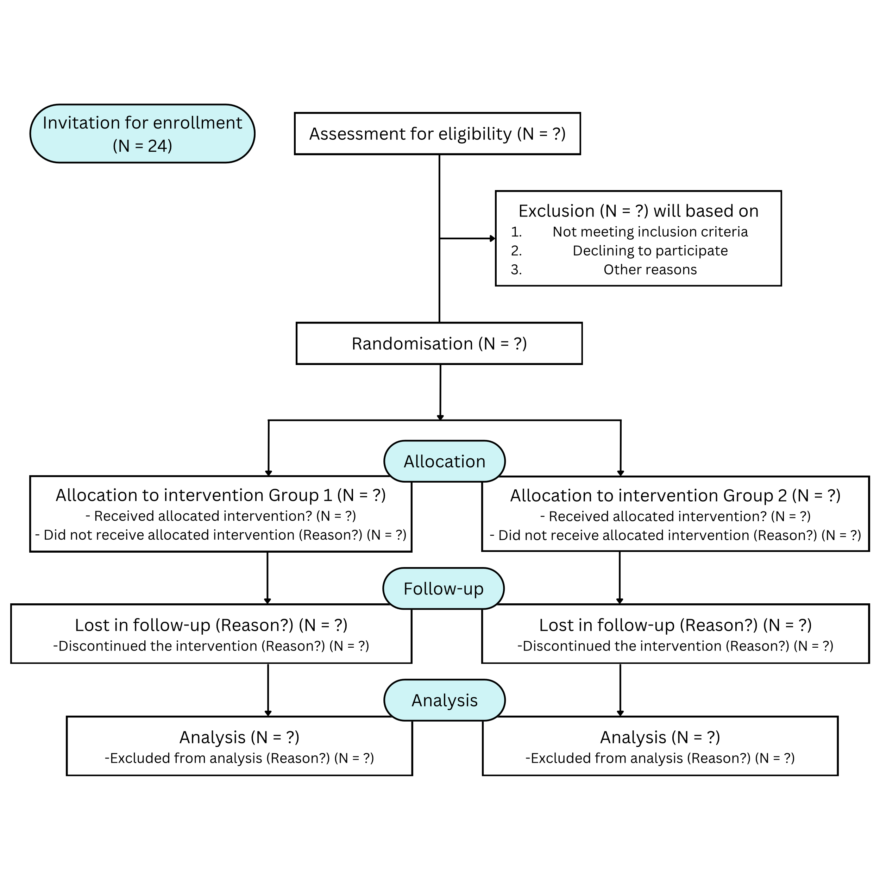
Figure 1 The CONSORT (Consolidated Standards of Reporting Trials) diagram
Includes detailed information on the trial's flow

2.2 Experimental Approach to the Problem:

Given the research question, a randomised, parallel-two-group, longitudinal (pre-test, post-test), quasi-time and sprint-volume matched experimental design will be used to assess the changes in soccer-related performance outcomes induced by RST protocols with two different inter-rep rest intervals. To ensure both groups are presented with equal pretraining average scores, the subjects will be matched according to their Baseline Test Results, Age, and BMI and will be randomly assigned to either a (10-sec; n = 12) or (20-sec; n = 12) inter-rep rest interval-based RST group with randomisation and allocation concealment being carried out as per CONSORT guidelines. Subjects are familiar with the testing protocols because tests being part of their regular training program. On the first day of testing, body mass, stature, LSS, and CMJ Height tests will be scheduled. MAS test will be scheduled on the second day, following a minimum of 24 hours of rest. Investigators will also explain the CR100 scale to the subjects during familiarisation sessions, which will be used to monitor perceptual measures of fatigue using dRPE. The study will be conducted during the soccer pre-season and include 1) Pre-training testing, 2) a 6-week RST-based intervention period, and 3) Post-training testing. All of the tests will be scheduled at a similar time of day under similar environmental conditions (temperature, wind speed, humidity). The study will follow the testing guidelines regarding order and selection, as evidenced in the literature (Jonathon Weakley et al., 2023).

2.3 Intervention Protocols:

These soccer players perform soccer-specific training twice a week on Monday and Thursday and play full-length games generally on weekends. The weekday training sessions typically last 90-120 minutes, including warm-up activities, physical conditioning, technical/tactical skills development, and active recovery strategies. During the 6-week intervention period, the regular physical conditioning sessions performed on Mondays and Thursdays will be replaced by the RST-based interventions to ensure 48-hour recovery between sessions. In contrast, the rest of the weekly schedule routine will be the same as before the study. This will ensure that the overall time exposure to training stays identical between the two experimental groups.
The two protocols will be quasi-time and sprint-volume matched to ensure the ~ 4-min overall recovery periods and sprint volume stay consistent across the two groups, as recommended by the recent meta-analyses (F. Thurlow et al., 2023; Fraser Thurlow et al., 2023; J. Weakley, A. Pérez Castilla, et al., 2023). The 10-sec protocol will consist of 4 sets of 3-4 repetitions of 35 m interspersed with 10-sec of inter-rep passive recovery and 80-sec inter-set passive recovery, whereas the 20-sec protocol will consist of 4 sets of 3-4 repetitions of 35 m interspersed with 20-sec of inter-rep passive recovery and ~ 60-67-sec inter-set passive recovery over the 6 weeks.
The detailed RST Program is as follows:
Table 2: Quasi-Time & Sprint-Volume Matched Repeated Sprint Training Program
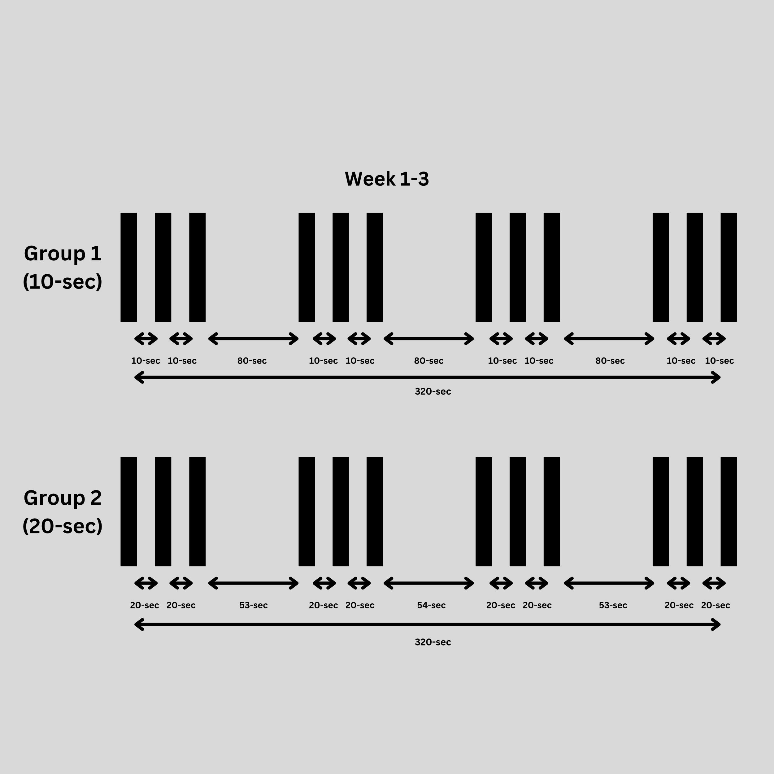
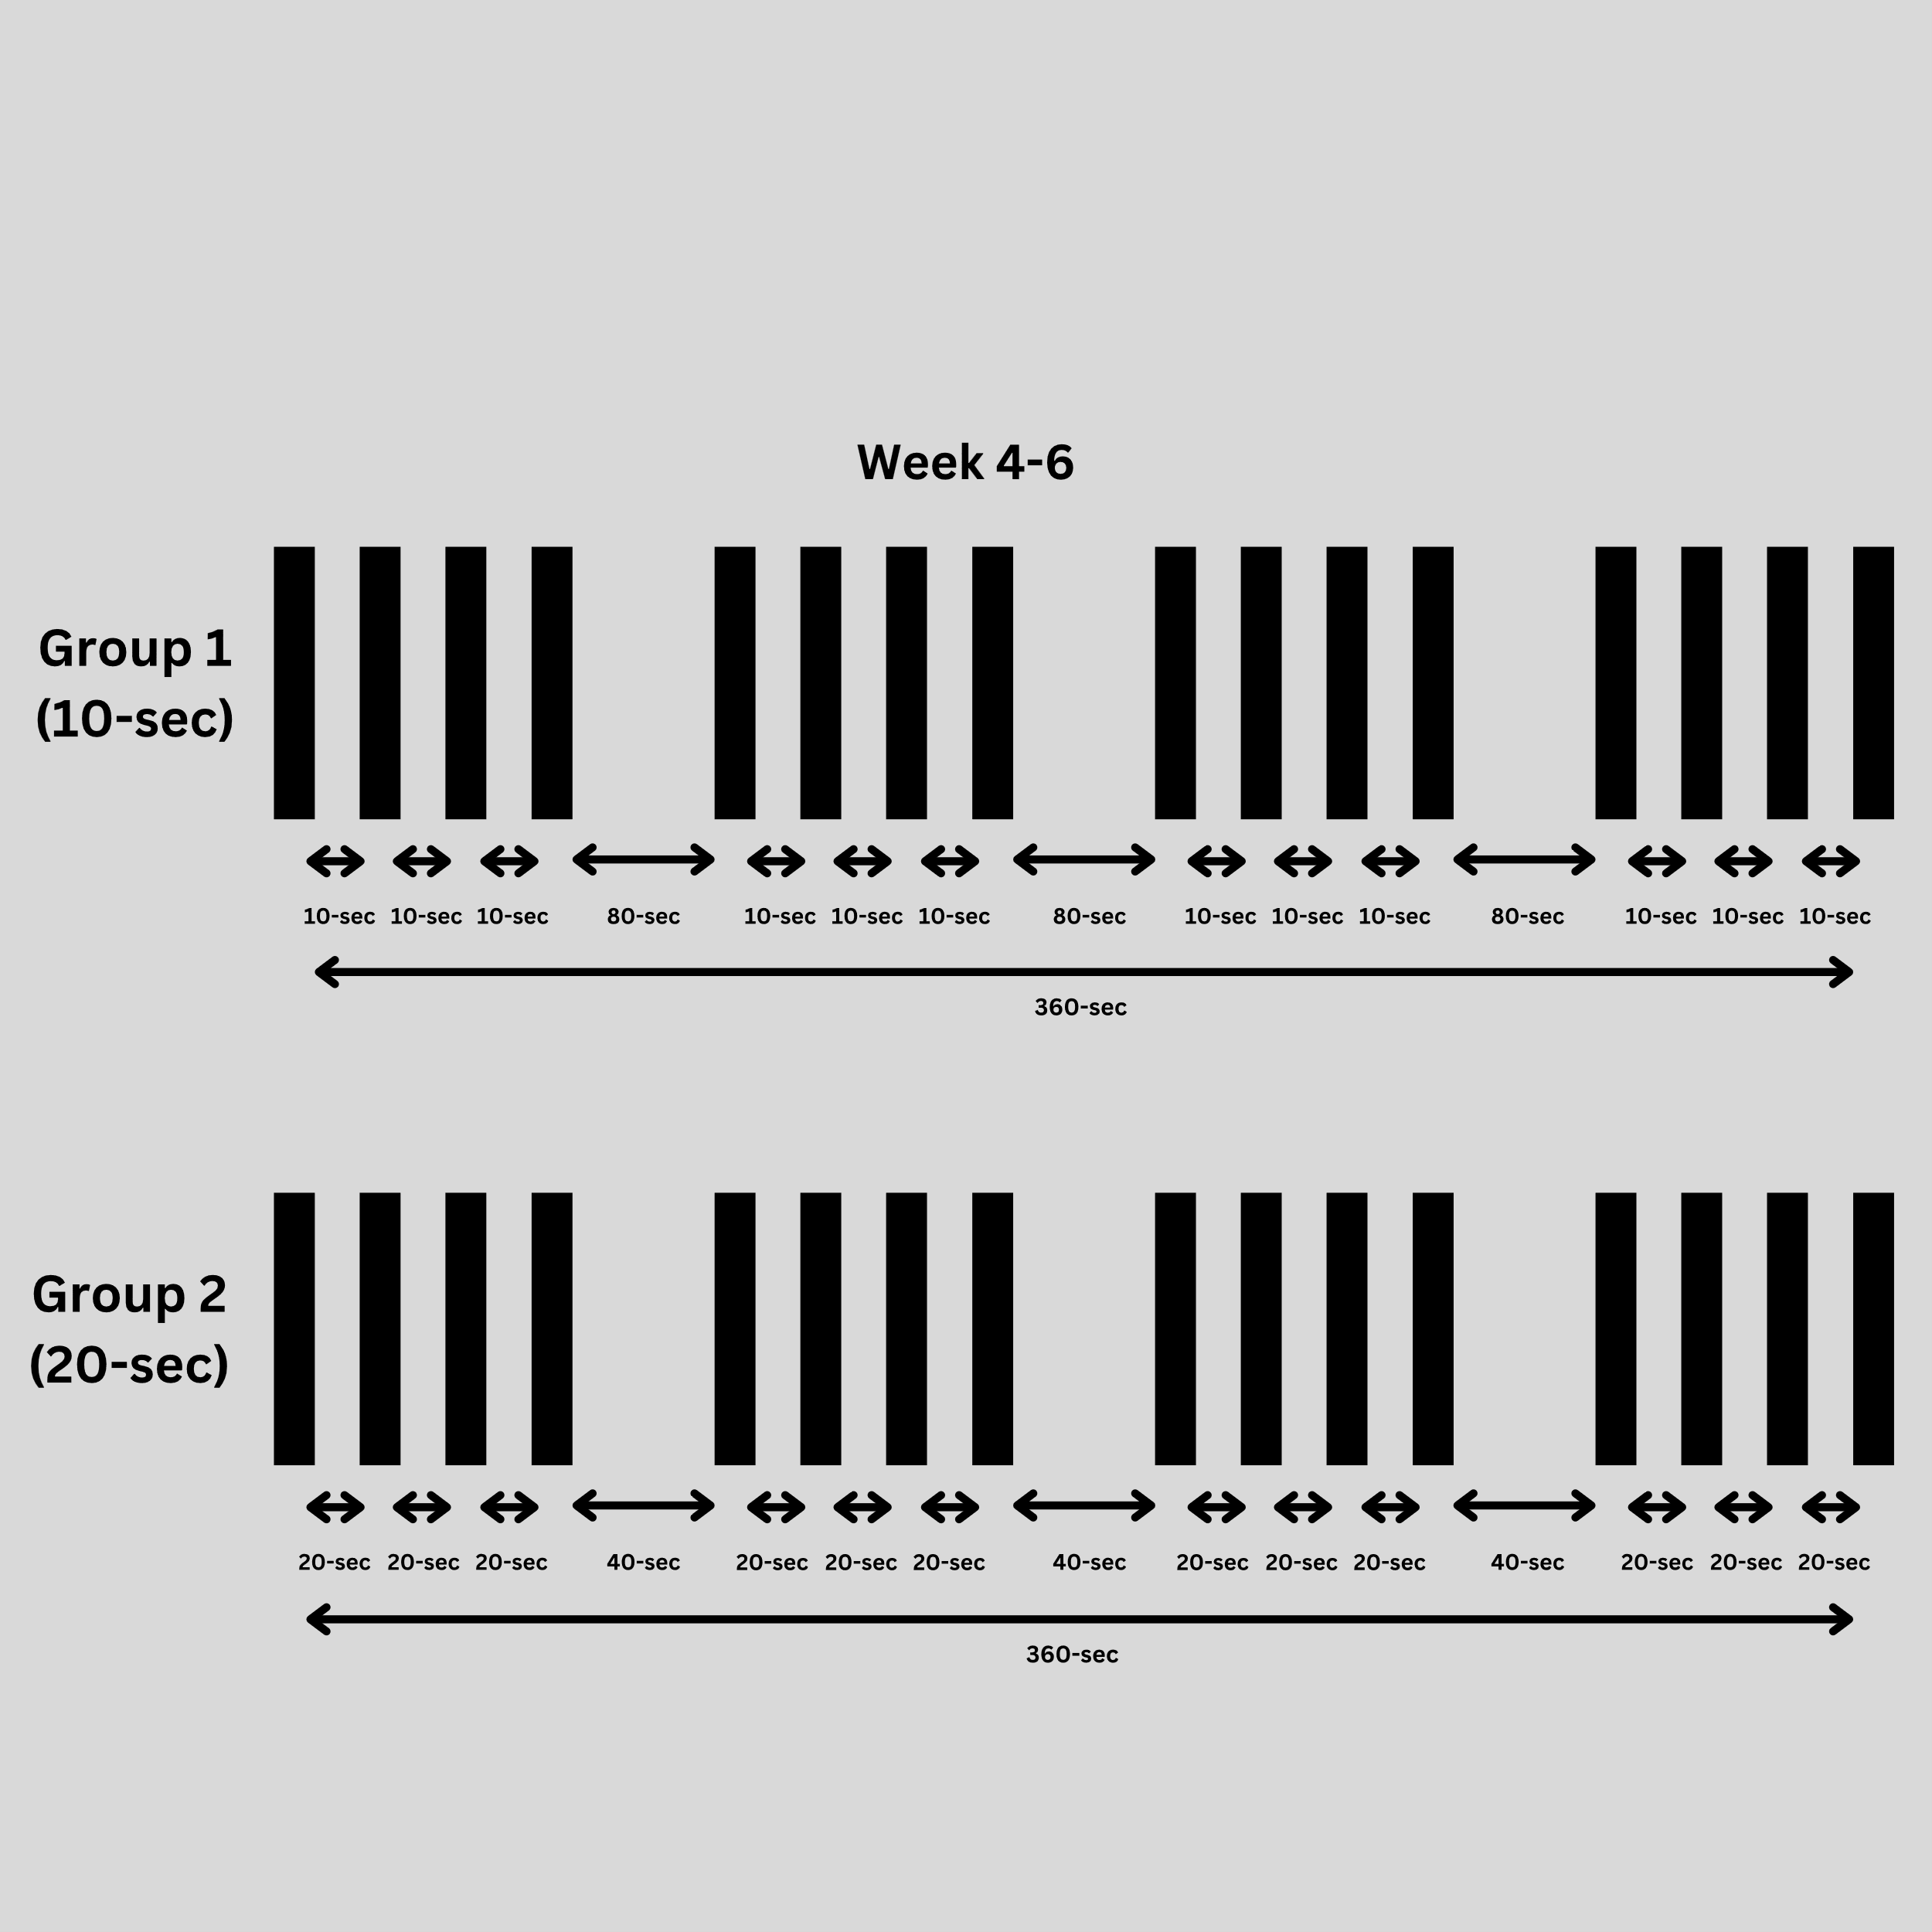
Figure 2: Visual Representation of RST Program Across Weeks 1-6
All of the participants will be supervised through a 10-15-minute dynamic warm-up using the RAMP protocol (Haff & Triplett, 2015). They will be instructed to perform 3 progressive sprints of 35 m at 50, 70, and 90% of perceived maximal effort (Marcote-Pequeño et al., 2019) as part of their familiarisation session and also as their specific RST protocol dynamic warm-up. All training sessions will occur on artificial turf and be carefully supervised. The subjects will be instructed to maintain their standard food intake and lifestyle during the experimental phase to minimise any potential interference of external variables.
2.3 Performance Tests:
All of the performance tests will be conducted within 7 days before the commencement and after the cessation of the intervention and will include:
- LSS
- MAS
- CMJ Height
- TL
Pre- and Post-testing sessions will always be preceded by a 10-15 min standardised warm-up, done under similar environmental conditions and at a similar time of day. Testing sessions will follow the testing guidelines, including the order of tests highlighted by (Jonathon Weakley et al., 2023). Before commencing the study, all subjects will be familiarised with the testing and training procedures at least once. Subjects will be instructed to consume a standardised meal approx. 3 hours before all of the testing and training protocols. As mentioned earlier, in the 72 hours before testing, all participants will be instructed to refrain from alcohol, should have standardised dietary composition/calories by maintaining a diet diary, refrain from intense physical activity and in the 12 hours preceding testing, should not consume caffeine. Subjects will be asked to utilise maximal intent for each effort, and the investigators will provide loud verbal encouragement wherever needed (Weakley, Wilson, et al., 2020).

2.3.1 LSS:
Mean and Peak Velocities of 20-m and 40-m Sprints will be assessed using Electronic Timing Gates (10-m Split) and 10-Hz GPS on artificial turf (Roe et al., 2017). Subjects will be instructed to start with their dominant foot in a 2-point position on a point 0.5 m behind the timing gate before each effort, with a 10-second warning and 3-second countdown provided for each repetition (J. Weakley, C. McCosker, et al., 2023). The between-trial recovery time will be three minutes of passive recovery. The best performance out of the three trials will be used for further analysis. The intra-class correlation coefficients (ICCs) and coefficient of variation (CoV) will be used to conduct test-retest reliability.
2.3.2 MAS:
MAS will be tested using 1600-m Time Trials with timing gates or stopwatch (Bellenger et al., 2015).
MAS will be calculated using:
$${MAS=TT}_{avgspeed}*\left(0.766+0.117*{TT}_{distance}\right)$$
*${TT}_{avgspeed}$ in kmph, *${TT}_{distance}$ in km

2.3.4 CMJ Height:
CMJ Height will be calculated using force plates. The impulse-momentum approach will be used to calculate jump height while keeping time-to-take-off and countermovement depth similar over multiple attempts. The best of three trials will be recorded to the nearest 0.5 inches or 1.0 cm. The fourth trial will be introduced if there is a constant upward trend in jump height over the last three trials (Bishop et al., 2021).

2.3.5 Training Load (TL):
TL (consisting of internal) will be calculated using perceptual measures of fatigue using dRPE (McLaren et al., 2016) (Weakley, McLaren, et al., 2020) recorded on the CR100 scale, HR using heart rate monitors, Session Duration and GPS metrics (Bredt et al., 2020). Subjects will be asked about their breathlessness perception and leg muscle exertion at the middle and end of the last repetition of protocol and will be required to point to the corresponding value on the CR100 scale.
Subjects will have to wear similar footwear and be fitted with the same heart rate monitor, numbered vest, and GPS unit across each testing occasion (Crang et al., 2021). The data file for each testing trial will be imported into a custom-made Microsoft Excel spreadsheet. It will be handled as per the ethics document.
2.4 Statistical Analysis:
Collected data will be checked for statistical assumptions. A paired t-test will be used to evaluate Pre-to-Post differences. A One-Way ANCOVA will be used to determine between-group differences, with baseline measurement being treated as a covariate. If a significant main effect is detected, a post-hoc analysis will be used for multiple pairwise comparisons. An alpha level will be set at 0.05. Cohen’s d effect sizes (ESs) with corresponding 95% confidence intervals will be calculated by pooling the between subject and residual standard deviation to evaluate between and within protocol differences. Effect size thresholds of <0.2 trivial, 0.2 small, 0.6 moderate, 1.2 large, and 2.0 very large will be reported based on the outcome (Hopkins et al., 2009). The group’s mean values and standard deviations will represent the data sets. IBM SPSS Version 29.0.2.0 (Corp, 2023) and RStudio (v4.1.2; R Core Team 2021) will be used for analysis.

3. Feasibility & Planning:

Table 3: Resources Required:
Measurement Metrics | Equipment
Height | Stadiometer
Body Mass | Scales
Training and Testing Setup | Measurement Tape, Cones, Access to Track or Artificial Turf
Heart Rate | Heart Rate Monitor
Sprint Times | Electronic Timing Gates
Training Load | GPS, Heart Rate Monitor, dRPE using CR100 Scale
dRPE | CR100 Scale
Maximal Aerobic Speed | Electronic Timing Gates and GPS
Linear Sprint Speed | Electronic Timing Gates and GPS
Counter Movement Jump Height | Force Plates
Environmental Conditions | Temperature, Wind, and Humidity using Weather Monitoring Device/App
Workforce | Preferably two investigators, a minimum of one
Subjects | Minimum of 21

3.1 Research Project Progress Timeline:

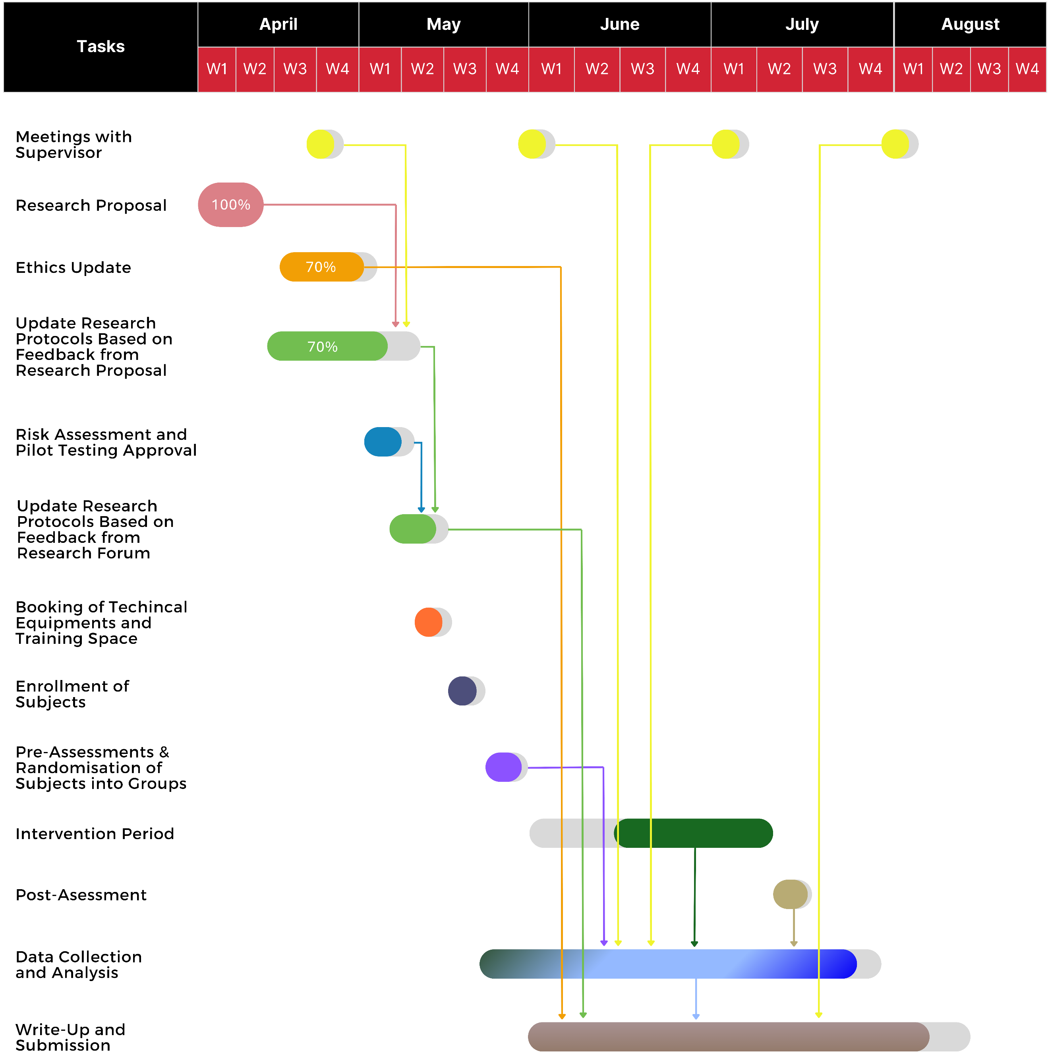

Figure 3: Research Project Progress Timeline

3.2 Tabel 4: Reflections on Risks Associated And Counter Measures:

- All of the resources mentioned above are available at ISPEHS Labs. However, access to the mentioned equipment might be tricky if my peers also want to use the same equipment in their projects across similar timelines. Hence, I will schedule the equipment booking with designated testing and assessment dates in advance to minimise this risk.
- I will conduct the testing, assessments and delivery of RST sessions in collaboration with the head soccer coach and head of physical preparation, who agreed to help carry out this study. To prepare for the worst-case scenario of conducting everything alone, I will ensure pre-assessment preparation, equipment check/setup, assessment schedule, instruction forms, and clear communication in advance. I will also perform a pilot trial to test the waters and learn from the experience.
- I already had a hands-on session with lab technicians to familiarise myself with the technical equipment. This has helped me tremendously in understanding how to use these novel equipment.
- I have CPR, AED, and First Aid qualifications, which will help me in unforeseen health calamities, provided the study's intensive nature. However, I will also request a lab technician to accompany me at least on testing days for more safety.
- Hydration plays a significant role in performance outcomes. Hence, I will instruct all of the athletes to stay hydrated throughout the protocol and will remind them to keep sipping on water both during testing and training protocols.
- Following discussions with athletes and the head of physical preparation, I discovered that the subjects are well-versed in the training and testing protocol, having utilised these tests in their standard training program. Therefore, the necessity for familiarisation sessions is contingent upon the percentage of subjects who have not already been exposed to the testing and training protocol.

References:

Bellenger, C. R., Fuller, J. T., Nelson, M. J., Hartland, M., Buckley, J. D., & Debenedictis, T. A. (2015). Predicting maximal aerobic speed through set distance time-trials. Eur J Appl Physiol, 115(12), 2593-2598. https://doi.org/10.1007/s00421-015-3233-6
Bishop, C., Turner, A., Jordan, M., Harry, J., Loturco, I., Lake, J., & Comfort, P. (2021). A Framework to Guide Practitioners for Selecting Metrics During the Countermovement and Drop Jump Tests. STRENGTH AND CONDITIONING JOURNAL, Publish Ahead of Print. https://doi.org/10.1519/SSC.0000000000000677
Bishop, D., Girard, O., & Mendez-Villanueva, A. (2011). Repeated-sprint ability - part II: recommendations for training. Sports Med, 41(9), 741-756. https://doi.org/10.2165/11590560-000000000-00000
Bortnik, L., Bruce-Low, S., Burger, J., Alexander, J., Harper, D., Morgans, R., Carling, C., McDaid, K., & Rhodes, D. (2023). Physical match demands across different playing positions during transitional play and high-pressure activities in elite soccer. Biology of Sport, 41, 73-82. https://doi.org/10.5114/biolsport.2024.131815
Bredt, S., Chagas, M. H., Peixoto, G. H., Menzel, H. J., & de Andrade, A. G. P. (2020). Understanding Player Load: Meanings and Limitations. J Hum Kinet, 71, 5-9. https://doi.org/10.2478/hukin-2019-0072
Chmura, P., Oliva-Lozano, J. M., Muyor, J. M., Andrzejewski, M., Chmura, J., Czarniecki, S., Kowalczuk, E., Rokita, A., & Konefał, M. (2022). Physical Performance Indicators and Team Success in the German Soccer League. J Hum Kinet, 83, 257-265. https://doi.org/10.2478/hukin-2022-0099
Corp, I. (2023). IBM SPSS Statistics for Windows, Version 29.0.2.0 In
Crang, Z. L., Duthie, G., Cole, M. H., Weakley, J., Hewitt, A., & Johnston, R. D. (2021). The Validity and Reliability of Wearable Microtechnology for Intermittent Team Sports: A Systematic Review. Sports Med, 51(3), 549-565. https://doi.org/10.1007/s40279-020-01399-1
Faude, O., Koch, T., & Meyer, T. (2012). Straight sprinting is the most frequent action in goal situations in professional football. J Sports Sci, 30(7), 625-631. https://doi.org/10.1080/02640414.2012.665940
Faul, F., Erdfelder, E., Lang, A.-G., & Buchner, A. (2007). G*Power 3: A flexible statistical power analysis program for the social, behavioral, and biomedical sciences. Behavior Research Methods, 39(2), 175-191. https://doi.org/10.3758/BF03193146
Freitas, T. T., Pereira, L. A., Reis, V. P., Fernandes, V., Alcaraz, P. E., Azevedo, P. H. S. M., & Loturco, I. (2021). Effects of a Congested Fixture Period on Speed and Power Performance of Elite Young Soccer Players. International Journal of Sports Physiology and Performance, 16(8), 1120-1126. https://doi.org/10.1123/ijspp.2020-0280
Girard, O., Mendez-Villanueva, A., & Bishop, D. (2011). Repeated-sprint ability - part I: factors contributing to fatigue. Sports Med, 41(8), 673-694. https://doi.org/10.2165/11590550-000000000-00000
Haff, G. G., & Triplett, N. T. (2015). Essentials of Strength Training and Conditioning 4th Edition. Human Kinetics. https://books.google.co.uk/books?id=bfuXCgAAQBAJ
Hill-Haas, S., Bishop, D., Dawson, B., Goodman, C., & Edge, J. (2007). Effects of rest interval during high-repetition resistance training on strength, aerobic fitness, and repeated-sprint ability. J Sports Sci, 25(6), 619-628. https://doi.org/10.1080/02640410600874849
Hopkins, W. G., Marshall, S. W., Batterham, A. M., & Hanin, J. (2009). Progressive statistics for studies in sports medicine and exercise science. Med Sci Sports Exerc, 41(1), 3-13. https://doi.org/10.1249/MSS.0b013e31818cb278
Iaia, F. M., Fiorenza, M., Larghi, L., Alberti, G., Millet, G. P., & Girard, O. (2017). Short- or long-rest intervals during repeated-sprint training in soccer? PLoS One, 12(2), e0171462. https://doi.org/10.1371/journal.pone.0171462
Jukic, I., Ramos, A. G., Helms, E. R., McGuigan, M. R., & Tufano, J. J. (2020). Acute Effects of Cluster and Rest Redistribution Set Structures on Mechanical, Metabolic, and Perceptual Fatigue During and After Resistance Training: A Systematic Review and Meta-analysis. Sports Med, 50(12), 2209-2236. https://doi.org/10.1007/s40279-020-01344-2
Laursen, P., & Buchheit, M. (2019). Science and Application of High-Intensity Interval Training: Solutions to the Programming Puzzle. Human Kinetics. https://books.google.co.uk/books?id=0vR6DwAAQBAJ
Marcote-Pequeño, R., García-Ramos, A., Cuadrado-Peñafiel, V., González-Hernández, J. M., Gómez, M., & Jiménez-Reyes, P. (2019). Association Between the Force-Velocity Profile and Performance Variables Obtained in Jumping and Sprinting in Elite Female Soccer Players. Int J Sports Physiol Perform, 14(2), 209-215. https://doi.org/10.1123/ijspp.2018-0233
McLaren, S. J., Graham, M., Spears, I. R., & Weston, M. (2016). The Sensitivity of Differential Ratings of Perceived Exertion as Measures of Internal Load. Int J Sports Physiol Perform, 11(3), 404-406. https://doi.org/10.1123/ijspp.2015-0223
Meckel, Y., Machnai, O., & Eliakim, A. (2009). Relationship among repeated sprint tests, aerobic fitness, and anaerobic fitness in elite adolescent soccer players. J Strength Cond Res, 23(1), 163-169. https://doi.org/10.1519/JSC.0b013e31818b9651
Negra, Y., Sammoud, S., Ramirez-Campillo, R., Bouguezzi, R., Moran, J., & Chaabene, H. (2023). The effects of repeated sprint training with versus without change of direction on measures of physical fitness in youth male soccer players. J Sports Med Phys Fitness, 63(1), 8-15. https://doi.org/10.23736/s0022-4707.22.13521-8
Oliva-Lozano, J. M., Fortes, V., Krustrup, P., & Muyor, J. M. (2020). Acceleration and sprint profiles of professional male football players in relation to playing position. PLoS One, 15(8), e0236959. https://doi.org/10.1371/journal.pone.0236959
Oliva Lozano, J., Fortes, V., López del Campo, R., Resta, R., & Muyor, J. (2022). When and How do Professional Soccer Players Experience Maximal Intensity Sprints in LaLiga? Science and Medicine in Football. https://doi.org/10.1080/24733938.2022.2100462
Owen, A. (2023). Football Science & Performance Coaching: Develop an Elite Coaching Methodology With Applied Coaching Science.
Rampinini, E., Coutts, A. J., Castagna, C., Sassi, R., & Impellizzeri, F. M. (2007). Variation in top level soccer match performance. Int J Sports Med, 28(12), 1018-1024. https://doi.org/10.1055/s-2007-965158
Roe, G., Darrall-Jones, J., Black, C., Shaw, W., Till, K., & Jones, B. (2017). Validity of 10-HZ GPS and Timing Gates for Assessing Maximum Velocity in Professional Rugby Union Players. Int J Sports Physiol Perform, 12(6), 836-839. https://doi.org/10.1123/ijspp.2016-0256
Saraslanidis, P., Petridou, A., Bogdanis, G. C., Galanis, N., Tsalis, G., Kellis, S., & Mougios, V. (2011). Muscle metabolism and performance improvement after two training programmes of sprint running differing in rest interval duration. J Sports Sci, 29(11), 1167-1174. https://doi.org/10.1080/02640414.2011.583672
Sarmento, H., Marcelino, R., Anguera, M. T., CampaniÇo, J., Matos, N., & LeitÃo, J. C. (2014). Match analysis in football: a systematic review. Journal of Sports Sciences, 32(20), 1831-1843. https://doi.org/10.1080/02640414.2014.898852
Stølen, T., Chamari, K., Castagna, C., & Wisløff, U. (2005). Physiology of soccer: an update. Sports Med, 35(6), 501-536. https://doi.org/10.2165/00007256-200535060-00004
Taylor, J., Macpherson, T., Spears, I., & Weston, M. (2015). The effects of repeated-sprint training on field-based fitness measures: a meta-analysis of controlled and non-controlled trials. Sports Med, 45(6), 881-891. https://doi.org/10.1007/s40279-015-0324-9
Taylor, J. M., Macpherson, T. W., Spears, I. R., & Weston, M. (2016). Repeated Sprints: An Independent Not Dependent Variable. International Journal of Sports Physiology and Performance, 11(5), 693-696. https://doi.org/10.1123/ijspp.2016-0081
Thurlow, F., Huynh, M., Townshend, A., McLaren, S. J., James, L. P., Taylor, J. M., Weston, M., & Weakley, J. (2023). The Effects of Repeated-Sprint Training on Physical Fitness and Physiological Adaptation in Athletes: A Systematic Review and Meta-Analysis. Sports Med. https://doi.org/10.1007/s40279-023-01959-1
Thurlow, F., Weakley, J., Townshend, A. D., Timmins, R. G., Morrison, M., & McLaren, S. J. (2023). The Acute Demands of Repeated-Sprint Training on Physiological, Neuromuscular, Perceptual and Performance Outcomes in Team Sport Athletes: A Systematic Review and Meta-analysis. Sports Medicine, 53(8), 1609-1640. https://doi.org/10.1007/s40279-023-01853-w
Turner, A. N., & Stewart, P. F. (2014). Strength and Conditioning for Soccer Players. Strength & Conditioning Journal, 36(4), 1-13. https://doi.org/10.1519/ssc.0000000000000054
Weakley, J., Black, G., McLaren, S., Scantlebury, S., Suchomel, T. J., McMahon, E., Watts, D., & Read, D. B. (2023). Testing and Profiling Athletes: Recommendations for Test Selection, Implementation, and Maximizing Information. Strength & Conditioning Journal, 10.1519/SSC.0000000000000784. https://doi.org/10.1519/ssc.0000000000000784
Weakley, J., McCosker, C., Chalkley, D., Johnston, R., Munteanu, G., & Morrison, M. (2023). Comparison of Sprint Timing Methods on Performance, and Displacement and Velocity at Timing Initiation. J Strength Cond Res, 37(1), 234-238. https://doi.org/10.1519/jsc.0000000000004223
Weakley, J., McLaren, S., Ramirez-Lopez, C., García-Ramos, A., Dalton-Barron, N., Banyard, H., Mann, B., Weaving, D., & Jones, B. (2020). Application of velocity loss thresholds during free-weight resistance training: Responses and reproducibility of perceptual, metabolic, and neuromuscular outcomes. J Sports Sci, 38(5), 477-485. https://doi.org/10.1080/02640414.2019.1706831
Weakley, J., Pérez Castilla, A., García Ramos, A., Banyard, H., Thurlow, F., Edwards, T., Morrison, M., McMahon, E., & Owen, C. (2023). Effect of Traditional, Rest Redistribution, and Velocity-Based Prescription on Repeated Sprint Training Performance and Responses in Semiprofessional Athletes. J Strength Cond Res, 37(8), 1566-1572. https://doi.org/10.1519/jsc.0000000000004438
Weakley, J., Wilson, K., Till, K., Banyard, H., Dyson, J., Phibbs, P., Read, D., & Jones, B. (2020). Show Me, Tell Me, Encourage Me: The Effect of Different Forms of Feedback on Resistance Training Performance. J Strength Cond Res, 34(11), 3157-3163. https://doi.org/10.1519/jsc.0000000000002887

